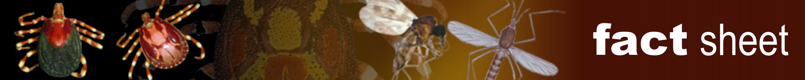
Tick control
Authors: Dr Reginald De Deken, Prof Ivan Horak, Prof Maxime Madder, Dr Hein Stoltsz
Licensed under a Creative Commons Attribution license.

Introduction
Different control strategies (chemical, biological and vaccines), principles of acaricide resistance, and the effect of tick control on endemic stability of tick-borne diseases are described, and information is provided on the different chemical products available.

Control
Control of ticks is essential in those areas where ticks are carriers and vectors of pathogens of humans and animals, or where they cause significant production losses in livestock. In cattle ticks are often controlled by plunge dips, spray races or pour-ons. Although efficient in reducing heavy tick burdens, intensive ticks control can disturb the endemic stability of a disease.

Acaricide resistance
Resistance to acaricides is the ability in a strain of tick to tolerate doses of acaricides that would prove lethal to the majority of individuals in a normal population of the same species.

Endemic stability of tick-borne diseases
Finding the equilibrium between endemic stability and tick control is not an easy task. Endemic stability is an epidemiological state in which clinical disease is low despite high levels of infection in the population. To achieve this, a sufficiently high number of infected ticks are necessary on the animals at a young age to ensure exposure to the pathogen before colostral and innate immunity wanes.

Find out more
- Tick Importance and transmission: The ticks of veterinary importance and the different routes of transmission, including transovarial, transtadial and intrastadial transmission are described.
- Identification of ticks: The systematics and taxonomy of ticks, the seasonal occurrence, different life cycles, tick morphology and identification and differential diagnosis of ticks of veterinary importance are described.
- Tick surveillance: Information is provided on the different collection methods of ticks, including vegetation sampling, nest/burrow sampling, tick traps and host sampling methods.

