Ticks
Tick identification
Authors: Prof Maxime Madder, Prof Ivan Horak, Dr Hein Stoltsz
Licensed under a Creative Commons Attribution license.

Seasonal occurrence / Life cycle

Seasonal occurrence
Long before scientists were aware of biological mechanisms controlling the life cycle of arthropods, early man had already noticed seasonality in certain species, especially edible ones. These were exploited as a source of food and information on the seasonal occurrence of the species was handed down from generation to generation. It was only in the beginning of the previous century that researchers performed well-planned experiments on certain arthropods and since then the number of species in which there is known to be a response to photoperiod and temperature rose logarithmically (Brown and Hodek, 1983). It became clear that most arthropods displayed a photoperiodically (daylength) controlled life cycle to synchronise their development stages with favourable climatic conditions. Some tick species show a semivoltine cycle in which the ticks need more than one year to complete the life cycle, a univoltine (1 cycle per year) or multivoltine (more than 1 life cycle per year) cycle.
Most ticks show seasonality in their life cycles; in most species the adult ticks will become active and feed at the start of the rains. This has been noticed by livestock keepers and scientists for years. Because of the great economic importance of certain ticks as vectors of diseases of domestic livestock and in particular cattle, the study of the seasonal occurrence of ticks is of major importance in the control of ticks and tick-borne diseases.
An increasing number of ticks have been studied during the last decennia and the seasonal responses and adaptations of their life cycles are much more complicated than expected previously. Seasonal activity is mainly determined by the activity or inactivity of the different life cycle stages.

Life cycle
All ticks have four stages: the embryonated egg and three active stages, namely the larva, one or more nymphal stages and the adult. Sexual dimorphism (phenotypic difference between males and females) is evident only in the adult stage. In the Argasidae (soft tick species), development is gradual, with multiple nymphal stages before reaching the adult form (multi-host life cycle), while in the Ixodidae (hard tick species), the development is accelerated, with only one nymphal stage. In most of the ixodid species, each active stage seeks a host, feeds, and drops off to develop further in the natural environment (three-host life cycle), but in few species, fed juveniles remain and develop on the host, shortening the life cycle (two-host and one-host ticks).

Life cycle of hard ticks
The fully fed female detaches and drops off the host and after a few days, known as the pre-oviposition period, lays a single large batch of several thousand eggs in a sheltered spot and then dies. After a period of weeks or even months minute six-legged larvae hatch from these eggs. These larvae are known as "seed" or "pepper" ticks because of their similar morphology to small seeds or crunched pepper corns. The larvae of some species climb up the stems of grasses or other plants and wait for a passing host to which they attach, while the larvae of other species wait for a host on the ground and then climb on and attach. Following attachment, they engorge and a period of quiescence follows while structural changes (partial metamorphosis) take place inside the skin of each larva. The larvae then moult into nymphs that require a few days for the integument to harden before they will attach. They engorge, go through a period of quiescence and moult to adults that also require a few days for the integument to harden before they will attach. The partially engorged female is attractive to the partially engorged male that migrates to where the female is attached, they mate, and the female engorges, detaches, drops to the ground and lays eggs. The male may remain on the host for months before finally dying. The integument of the female undergoes physiological changes during the last 24 hours of engorgement. These changes make her less susceptible to desiccation and she also becomes less susceptible to the effects of acaricides.

One-host life cycle
Larvae hatch from eggs, climb on to a host, attach, engorge, moult on the host to nymphs, nymphs attach, engorge, moult on the host to males and females, adults attach, partially engorge, mate, females engorge fully, detach, drop to the ground, lay a single large batch of eggs in a sheltered locality and die. The next generation of larvae hatches from these eggs. The demographic structure of a parasitic population of one-host ticks is eight larvae to four nymphs to two males to one female. The population has this structure because it has been calculated that half the larvae do not successfully moult to nymphs. Some are probably lost by the host grooming itself, others during the moulting process. Similarly only half the nymphs will successfully moult to adults. The difference in proportions between adult male and female ticks is possibly due to the larger females being more likely to be removed by host grooming, but more likely because engorged females engorge and detach from the host whereas the males can remain on the host for several weeks, resulting in a preponderance of male ticks.
The advantage of one- and two-host ticks is the relatively protected environment that the hosts offer to the vulnerable larval and nymphal stages. In this way, the immature stages are not exposed to hostile climatic conditions, which reduces mortality.
Disease transmission of one-host ticks is limited to transovarial transmission where infection is passed from one generation to the next via eggs.

Two-host life cycle
Larvae hatch from eggs, climb on to the first host, attach, engorge, moult on the host to nymphs, nymphs attach, engorge, detach, drop to the ground, moult to males and females in a sheltered locality, adults climb on to the second host, attach, partially engorge, mate, the females fully engorge, detach, drop to the ground, lay a single large batch of eggs in a sheltered locality and die.
Transmission of pathogens can be transovarial from one generation to the next via ovaries or transstadial from the nymphal to the adult stage.
In some species, e.g. Hyalomma anatolicum anatolicum host availability can influence the life cycle; it can feed on hares as a two-host tick for its entire life cycle and on cattle as a three-host tick.

Three-host life cycle
After oviposition, hatching of the eggs begins after a few weeks or a month depending on the temperature. The emerged larvae disperse into the vegetation or nest to seek hosts after hardening. Once attached to a passing host, larvae feed slowly (several days) to repletion. The engorged larvae drop from their host and find a sheltered micro-environment. Ecdysis (=moulting) starts after several days. The newly emerged nymphs harden and again seek hosts (sometimes the same hosts as those fed upon by the larvae). They in turn attach, feed and drop from the host as engorged nymphs. They too try to find an appropriate niche to shelter and moult into adults. After hardening, male and female ticks start questing, attach, feed and mate after a small initial blood meal. Female ticks engorge to repletion after mating, drop off and find a suitable place to oviposit and finally die. Males on the other hand, can mate several times before they die. The engorgement weight of the females can sometimes be 100 X the unfed adult weight. About 50% of this weight is converted to egg. The largest egg mass ever recorded from a single Amblyomma nuttalli consisted of 22 891 eggs.
The three-host life cycle is the most common development pattern and is characteristic of the vast majority of the species. It is the least evolved of the various life cycle patterns and huge losses in numbers occur between the larval and nymph stages and between the nymph stage and adults. . Transmission of pathogens can be transovarial, transstadial and intrastadial.

Life cycle of soft ticks
The life cycle of the argasid tick species is more diverse than the much more uniform pattern found in the ixodid tick species. Some soft ticks seek hosts by questing on low-lying vegetation, but the vast majority are nest parasites, residing in sheltered environments such as burrows, caves, or nests. Certain biochemicals such as carbon dioxide as well as heat and movement serve as stimuli that guide host-seeking behaviour. The feeding behaviour of many soft ticks can be compared to that of fleas or bedbugs, as once established, they reside in the nest of the host, feeding rapidly when the host returns. The outside surface, or cuticle, of soft ticks expands, but does not grow to accommodate the large volume of blood ingested, which may be anywhere from 5-10 times their unfed body weight. Argasid ticks feed rapidly, females feed and oviposit frequently (multiple gonotropic cycles) and deposit small egg masses (< 500 eggs/cycle). There are also 2 - 7 nymphal stages (moults) in the life cycle.
In the majority of species, larvae seek hosts, feed within 15 - 30 minutes and drop off to moult in the sand, duff or cracks and crevices of the natural habitat. Ornithodoros larvae don't feed and moult immediately to the nymphal stage. The first stage nymphs resemble the adults, but are smaller, lack the genital pore and any evidence of dimorphism. They in turn attack hosts, feed rapidly and moult again to another nymphal stage. The cycle of host seeking, feeding and moulting can be repeated up to 7 times in the nymphal stage. After the last nymphal moult, adult ticks become sexually active and they do not require a blood meal to initiate gametogenesis. Mating occurs before as well as after feeding, but rarely if ever on the host itself. Otobius adults do not feed at all.
Following feeding, oviposition begins and once completed, the ticks remain vigorous, seek new hosts, feed and oviposit again. This pattern of repeated gonotropic cycles enables argasid ticks to spread their progeny gradually over time, often across a span of many years. Diapause can be a major factor regulating the time of development of many of the argasid species, which survive in empty burrows or nests for periods of many months or years until their hosts return or new hosts arrive.
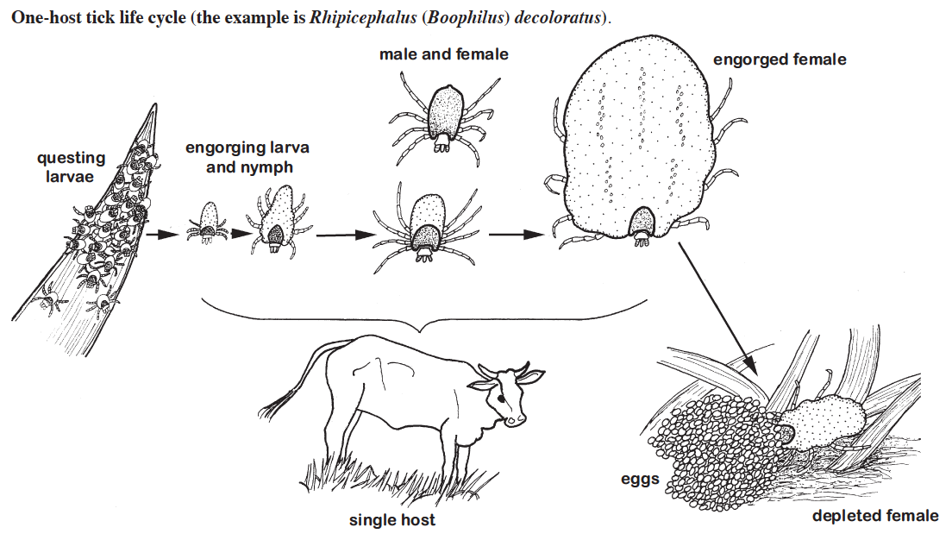
One-host life cycle. The example is Rhipicephalus decoloratus. From “Ticks of Domestic Animals in Africa” (Walker et al., 2003).

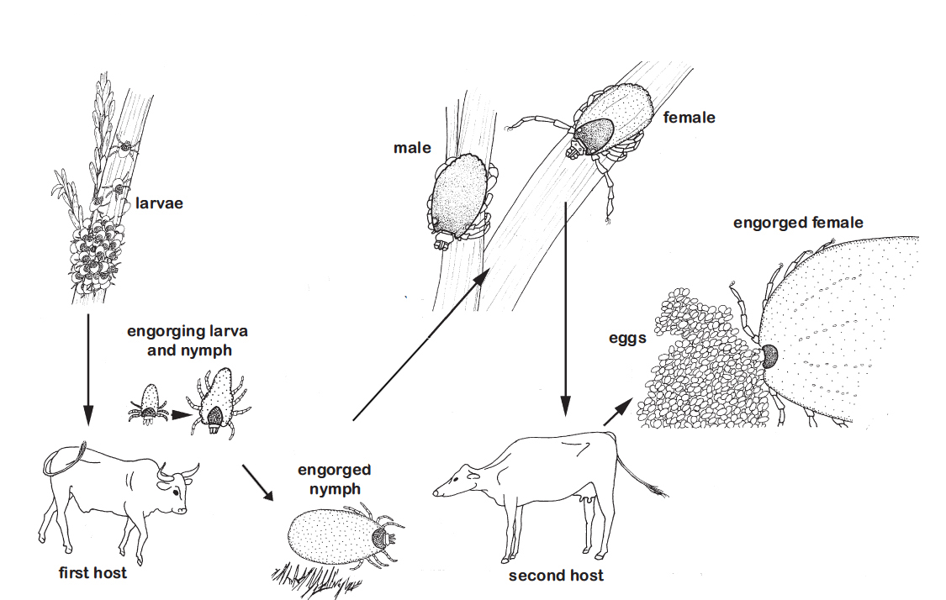
Two-host life cycle. The example is Rhipicephalus bursa. From “Ticks of Domestic Animals in Africa” (Walker et al., 2003).
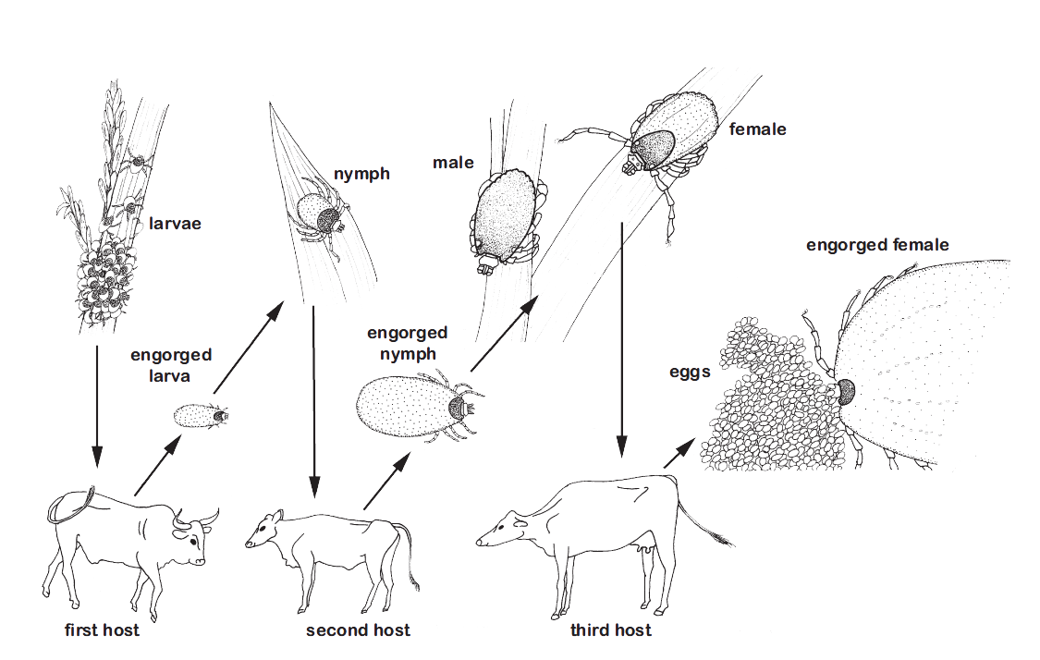

Three-host life cycle. The example is Rhipicephalus appendiculatus. From “Ticks of Domestic Animals in Africa” (Walker et al., 2003)
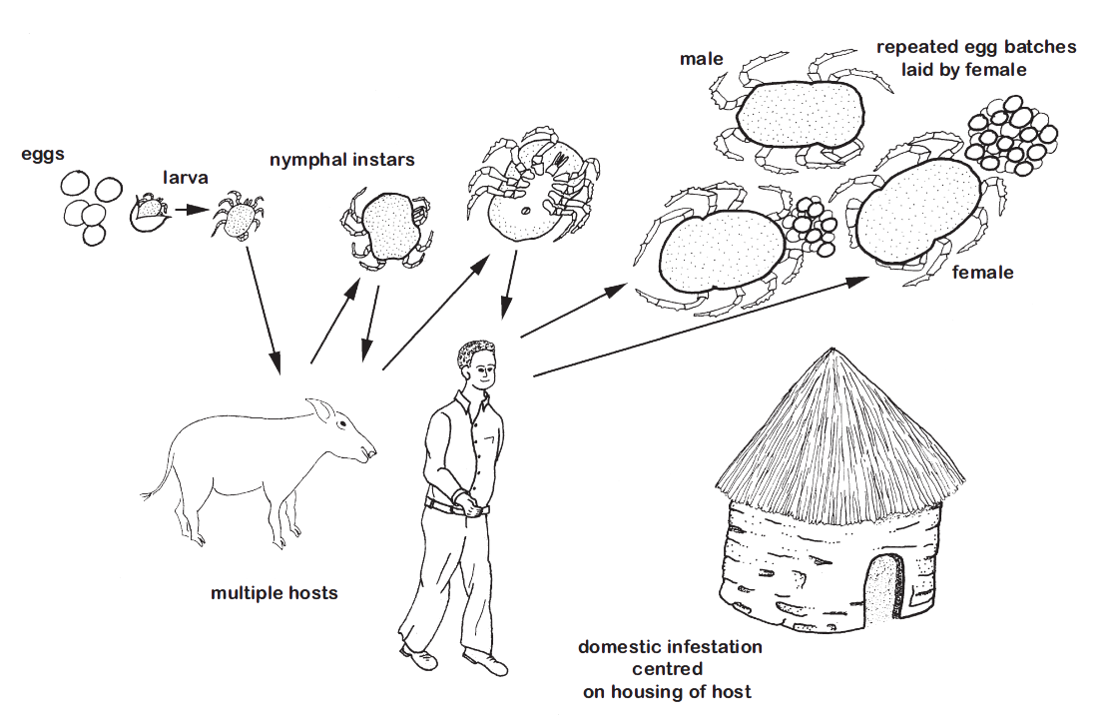

Argasid tick life cycle. The example is Ornithodoros moubata group, other argasid ticks may differ considerably. From “Ticks of Domestic Animals in Africa” (Walker et al., 2003).

