Ticks
Tick identification
Authors: Prof Maxime Madder, Prof Ivan Horak, Dr Hein Stoltsz
Licensed under a Creative Commons Attribution license.

Systematics/Taxonomy
Both soft (Argasidae) and hard (Ixodidae) ticks are members of the following taxonomic groups:.
Phylum Arthropoda
Subphylum Chelicerata
Class Arachnida
Subclass Acari
Order Parasitiformes
Suborder Ixodida (=Metastigmata)
Family Ixodidae
Phylum Arthropods: invertebrate, bilateral symmetry, chitinous skeleton with articulating segments and/or appendages.
Subphylum Chelicerata: modified first appendages, chelicerae, used for grasping, piercing, cutting and other functions associated with food gathering and feeding. The body is divided into two parts, (1) the prosoma and (2) the opisthosoma (see figure below).
Class Arachnida bear pedipalps, the modified second pair of appendages and four pairs of walking legs, all found on the prosoma (gnathosoma + podosoma). In contrast with the insects, arachnids lack a clearly defined head, so that the anterior body segments bearing the chelicerae and palps, are integrated with the posterior segments bearing the walking legs to form the prosoma.
Subclass Acari: exhibit extreme fusion of the body segments. The podosoma and the opisthosoma are fused, forming the idiosoma. In contrast with other arachnids, the opisthosomal region lacks distinct segmentation while the mouthparts are joined to a separate body region, the gnathosoma (= capitulum in ticks). Ticks and mites belong to this Subclass.
Mites comprise a vast assemblage of species, which inhabit terrestrial, marine and fresh water habitats. Mites occur in soil, fresh and brackish and salt water at all depths, in and on vegetation, in nests and burrows of vertebrates, and on the bodies or even in the internal organs of various vertebrate and invertebrate animals. Many are free-living as herbivores, fungivores, and predators; others are parasitic, including both ectoparasitic and endoparasitic adaptations. About 35 000 species have been described, another 1 000 000 undescribed species are believed to exist.
The Acari are subdivided into two major orders:
Parasitiformes: which have stigmatal pores (i.e., respiratory pores) on the podosomal and/or opisthosomal portion of the body, and have well-developed, freely articulated coxae,
Acariformes: which lack stigmata and typically have the coxae fused with the ventral body wall.
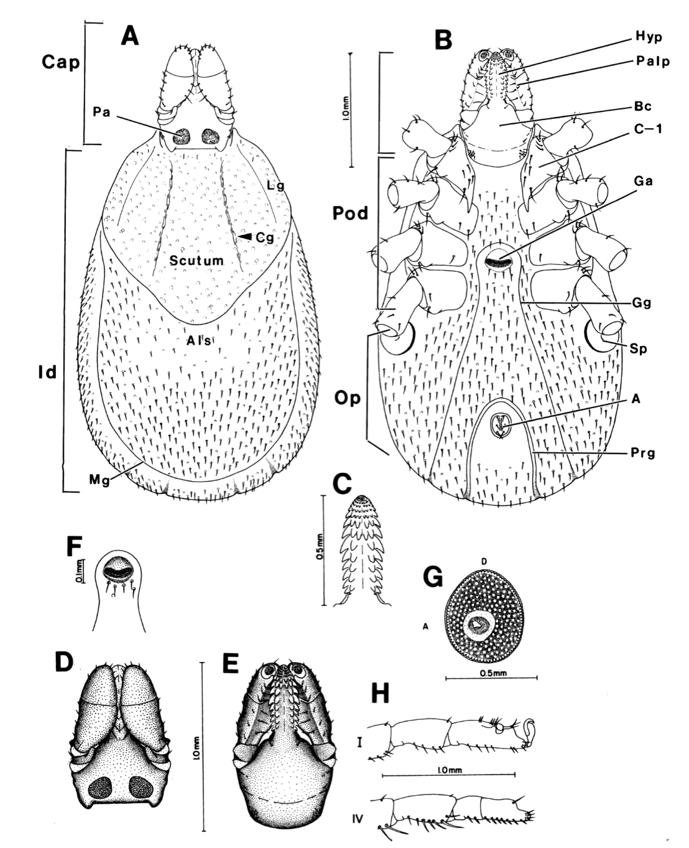
Diagrams illustrating the external anatomy of a representative ixodid tick female (Ixodes cookei).
A, Dorsal aspect. B, Ventral aspect. C, Hypostome, ventral aspect. D, Capitulum, dorsal aspect. E, Capitulum, vetral aspect. F, Genital aperture and genital groove. G, Spiracle. H, Terminal segments of legs. I, Trochanter and tarsus of leg. I. A = Anus; Als = alloscutum; Bc = basis capitlu; C-1 = coxa I; CAP = capitulum; Cg = cervical groove; Ga = genital aperture; Gg = genital groove; Hyp = hypostome; Id = idiosoma; Lg = lateral groove; Mg = marginal groove; OP = opisthosoma; Pa = porose area; Pod = podosoma; Prg = preanal groove; Sp = spiracle.

Ticks constitute the suborder Ixodida (=Metastigmata), a suborder of the order Parasitiformes. They are obligate blood-feeding parasites with a single pair of stigmata located posterior to the third or fourth pair of coxae in post-larval stages. In addition, the hypostome is enlarged, protuberant, and bears retrograde denticles for anchoring the tick into its hosts tissue and the dorsal surface of tarsus I bears a distinct sensory organ, Haller’s organ.
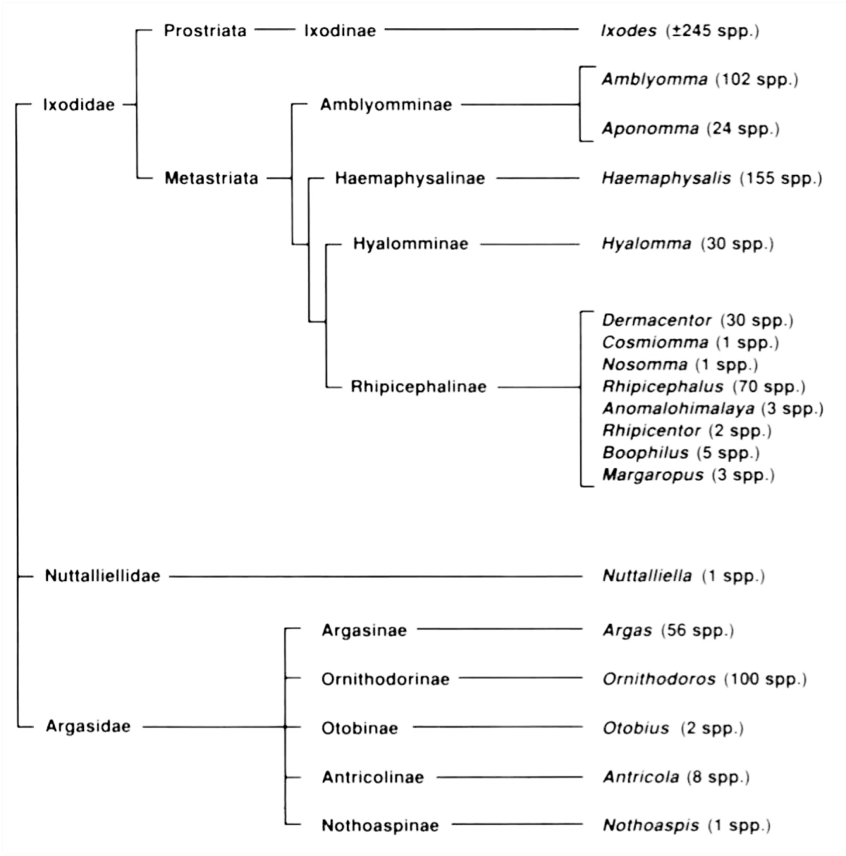
Genera of the three different tick families
The suborder Ixodida comprises three families:
- Ixodidae or hard ticks, with 14 genera and approximately 700 species/subspecies;
- Argasidae or soft ticks, with 5 genera and approximately 190 species; and
- Nuttaliellidae with only one species Nuttalliella namaqua.

